Epics Purdue; Fall 2019; Project team Wolf

Wolf Park Application User Guide
Author: Adam Popper; apopper@purdue.edu

Abstract:
This document will cover information pertaining to the maintenance and how to update the content of the application built for the Wolf park interactive map kiosk application. We will start by we will go over general information about the application operations during regular operation. Then going over setup instructions as well as tips and guides for debugging an issue with the kiosk hardware/application.we will end with guides and tips to updating content on the application itself. Finally we will end with guides and tips to updating content on the application itself.

Table of Contents:
Abstract……………………………………………………………………………………………… 1
Introduction ……………....…………………………………………………………………………. 3
Introduction to the Application……………………………………………………………... 3
Introduction to the Hardware……………………………………………………………… 3-4
Getting started ………………………………………………………………………………………. 5
Functionality Check………………………………………………………………………… 5
Power Supply Check……………………………………………………………………….. 5
Button Check…………………………………………………………………………………5
Problem Reference…………………………………………………………………………………. 6-7
Application Issues…………………………………………………………………………… 6
Button/Hardware Issues……………………………………………………………………....7
Updating Application…………………………………………………………………………………8-9
Updating Content……………………………………………………………………………. 8
Updating Maps………………………………………………………………………………. 8
Updating Application Version……………………………………………………………….. 8

Introduction:
Introduction to the Application:

In this section we will go over all of the components of the kiosk application and explain what the look like when the system is all working.

Component list:
- Raspberry Pi: This is the on board computer allowing low level graphics output and runs that application
- Project folder “WOLF_PY”: this can be found on the desktop of the raspberry pi or on the Fall 2019 software leads git: https://github.com/poppeada000/Wolf_PY

Functionality:
When the device gets plugged in, the raspberry pi should boot up to the application removing any mouse and keyboard functionality. Once the application boots, click the buttons, which should allow you to change from one page to the next and then finally times out any page after 20 seconds of being on it. The last part of the application is the maintenance button on the inside of the kiosk, this should close the application and bring you to the device desktop for maintenance.

Introduction to the Hardware:

In this section we will go over all of the components of the kiosks electrical hardware and explain what interactions look like when the system is all working.

Component list:
- Raspberry Pi: This is the on board computer allowing low level graphics output and runs that application
  - Needed supply voltage of 5V
- Content Buttons: These buttons after boot will allow the application to switch from one content page to the next using the GPIO pins.
  - Voltage supplied by GPIO pins
  - For wiring guideline visit page
- Main Screen: This is the main display screen that is connected to the raspberry pi through an hdmi connector.
  - Power is supplied by separate power block on distribution board
- Power Distribution Board: This is the main powerstrip supplying power to the entire kiosk
  - This will act as main power control and will need to be connected to a wall outlet.

Functionality:
When the device gets plugged in, the raspberry pi should boot up to the application. You should see the main display power up and see a boot running on the main screen. Once the application boots, click the buttons, which should allow you to change from one page to the next and then finally times out any page after 20 seconds of being on it. The last part of the application is the maintenance button on the inside of the kiosk, this should close the application and bring you to the device desktop for maintenance.

Getting Started:
In this section we will go through simple tests that will allow for any user to be able to debug most issues with the application or the hardware.

Functionality Check:
When the device gets plugged in, the raspberry pi should boot up to the application. You should see the main display power up and see a boot running on the main screen. Once the application boots, click the buttons, which should allow you to change from one page to the next and then finally times out any page after 20 seconds of being on it. The last part of the application is the maintenance button on the inside of the kiosk, this should close the application and bring you to the device desktop for maintenance.

If the application exhibits these behaviors it can be deemed as functionally running, but if the application does not follow ALL of these behaviors the application is not running properly.

Power Supply Check:
This test is rather simple test. Connect the kiosk output power (a singular plug) to the wall. Then the TV screen should come to life and the raspberry pi should boot up and load the application.

Button Check:
Once the application boots the buttons should begin to work immediately. In order to consider the buttons functional they must allow you to go to any content page from any other content page.

Problem Reference
This section of the user guide is focused on helping debug a variety of issues with the application and will attempt to explain how you should fix any issue.

Application Issues:
This section will focus on the software application that is running on the raspberry pi.
Application Not Booting:
How to Identify:
- The Application does not start when device is booted
- The screen is completely dark after a power cycle (plugged in)
- The cursor is visible on the screen
Solution: There are many issues that could cause this if this was immediately after the application was updated, please reference the Application Not Updating Properly section. The only solution that could be conducted for this issue is to run a power cycle(unplug and then plug back in) the kiosk.
If Solution does not work contact Purdue EPICS for maintenance

Application Not Updating Properly:
How to Identify:
- The Application boots with previous content on the content pages
- Immediately after an update the application boots to a black screen
- The content pages do not reflect the updated content
Solution: There are many issues that could cause this if this was immediately after the application was updated, please resort back to previous content or check the new content for any issues (note that the content pages are limited with respect to how much can be displayed). Contact the EPICS team at Purdue of the issue and they will be able to set the content page (as needed) to support extended content.
If Solution does not work contact Purdue EPICS for maintenance

Button/Hardware Issues:
Buttons Not Allowing to Switch to Content pages:
How to Identify:
- Upon completion of the kiosk boot cycle the buttons not allowing navigation from page to page
- Upon completion of the kiosk boot cycle the buttons not timing out, meaning the application doesn’t resort back to the homepage.
Solution: This is one of the few issues that can be solved by accessing the raspberry pi and checking to make sure the following wiring diagram is followed:
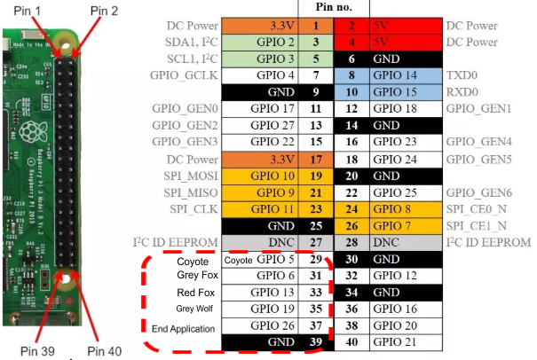
If Solution does not work contact Purdue EPICS for maintenance

Updating Application
Updating Content:
How to update:
- Hit the End application button on the inside of the kiosk to close out the application
- Connect a mouse and keyboard to the usb ports on the PI
- Click on the Wolf_PY folder on the device desktop
- Select the src folder and then the content folder
- Select witch content page you would like to update
- Make changes to the content(s) of all of the .txt files that you would like to change and SAVE the file(s) before closing.
- Turn the kiosk off and then back on
- The application should boot with new content if not go to the problem reference section of this document.

Updating Maps: This code was not completed and will be filled out once the Map feature is fully integrated into the application.

Updating Application Version:
How to update:
- Hit the End application button on the inside of the kiosk to close out the application
- Connect a mouse and keyboard to the usb ports on the PI
- Delete the Wolf_PY folder on the device desktop
- Copy the new application version folder to the desktop
- Turn the kiosk off and then back on
- The kiosk will boot with the new version

